**ULTRA GRIPPER PRODUCT SPECIFICATIONS**

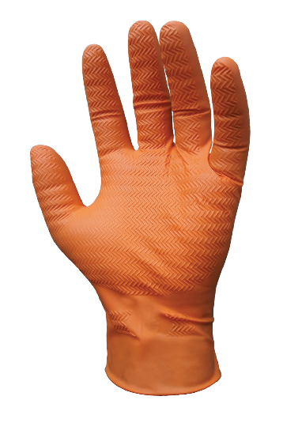

**Name of Product** - Ultra Grip Powder free Nitrile Gloves.

**Name of Manufacturer**  - Innovative Gloves Co. Ltd. Hatyai, Thailand.

**Base Material**  - Nitrile.

**Characteristics** -Non-Sterile, Ambidextrous.

**Available Sizes** - Small, Medium, Large, X-Large, XX-Large, XXX-Large.

**Surface** - Ultra Gripper.

**Surface Treatment** - Polymer Coated.

**Colour**  - Orange.

**Total Residue Content** - < 2.0 Milligrams per glove.

**Physical Specifications:**

|  |  |  |  |  |  |  |  |
| --- | --- | --- | --- | --- | --- | --- | --- |
| **Size** | **Length(mm/inch)** |  | | **Thickness(mm)**  **Single Wall** | | | **Width(mm)** |
| Tip Smooth Surface | Tip Textured Surface | | Palm Textured Surface | Cuff Smooth Surface |
| Small | 240±5 | 0.24±0.01 | 0.36±0.02 | | 0.27±0.01 | 0.13±0.01 | 85±5 |
| Medium | 240±5 | 0.24±0.01 | 0.36±0.02 | | 0.27±0.01 | 0.13±0.01 | 95±5 |
| Large | 240±5 | 0.24±0.01 | 0.36±0.02 | | 0.27±0.01 | 0.13±0.01 | 105±5 |
| X-Large | 240±5 | 0.24±0.01 | 0.36±0.02 | | 0.27±0.01 | 0.13±0.01 | 115±5 |
| XX-Large | 240±5 | 0.24±0.01 | 0.36±0.02 | | 0.27±0.01 | 0.13±0.01 | 125±5 |
| XXX-Large | 240±5 | 0.24±0.01 | 0.36±0.02 | | 0.27±0.01 | 0.13±0.01 | 130±5 |

**Tensile (D412 & EN 455-2)**

**Before Aging**

|  |  |  |
| --- | --- | --- |
| **Tensile(MPA)** | **Elongation(%)** | **Force At Break(N)** |
| 22 Mpa Min. | 500 Min. | ≥ 6 N |

**After Accelerated Aging**

|  |  |
| --- | --- |
| **Tensile(MPA)** | **Elongation(%)** |
| 22 Mpa min. | 400 Min. |

**Packaging**

|  |  |
| --- | --- |
| **Packaging (Normal)** | 50±1,100±2 pieces in one Dispenser Box,10 Dispenser Box in one Carton. |
| **Labeling on Dispenser (Normal)** | Product Name, Size, Lot no. Quantity, Manufacturer’s address, Warning about Latex Allergy. |
| **Labeling on Carton (Normal)** | Product Name, Size, Lot no. Quantity, Country of Origin. |

**Container Loadability** (No MOQ in manufacturer owned brand in standard Packaging)

|  |  |
| --- | --- |
| 20 FCL=1135 Cartons. | 40 FCL=2280 Cartons. |

,

**Certification**

A close up of a logo

Description generated with very high confidence